Machine Learning
Learning from the data – different patterns – to make predictions
Ex:
Train a student – teacher providing examples (data), they learn patterns(modeling), and then apply the knowledge to solve new problems(prediction)

ML Model ?
- Mathematical structure / algorithm which captures patterns in data
Ex:
- Input features like house size, location, no.of rooms
- Model linear regression
- Output house price

Categories of ML-models
Supervised learning
  - The model learns from labeled data – each input has a known output
  - Goal – predict outcomes for new data based on patterns learned from past data
- Regression
  - Out put continuous variable
  - Ex predicting house prices based on location, square foot etc
    - Input X = [size, location, no.of rooms]
    - Output Y = price
- Classification
  - Ouput categorical variable
  - Ex email spam detection
    - Input X = email text features
    - Ouput Y = spam or ham
Unsupervised learning
  - Model explore structure in data without labeled outputs
  - Goal discover hidden patterns / group
- Clustering
  - Output group assignments (no predefined labels)
  - Ex customer segmentation
    - Input X – [age, income, spending score]
    - Output – ex group A, B, C

Train-Test split in supervised learning

Training data used to fit the model – it learns patterns from this data
Testing data used to evaluate the model – checks how well it generalizes to unseen data

Types of linear regression

Simple linear regression
- One independent variable
- Equation – 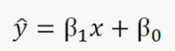 + error term
- Ex – predicting salary based on years of experience

Multiple linear regression
- Multiple independent variables
- Equation =
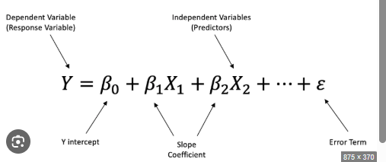

Ex predicting house price based on size, location , no.of rooms

Finding best fit line
Minimize the cost function – residual sum of squares (RSS)
Methods
- Differentiation
  - Use calculus to find min of RSS
  - Works for simple models
- Gradient descent
  - Iteratively adjusts coefficients to minimize the RSS
  - Essential for large scale models / non-linear

R square / R^2

- 1 – (RSS / TSS)
Residual sum of squares = RSS error between predicted value and actual value
Total sum of squares = TSS total variance in the data
Interpret
- R^2 = 1 perfect fit
- R^2 = 0 model explains none of the variance
- R^2 is higher better model performance

Ex think of R^2 as the percentage of variation in house prices that model can explain using features like size and location

- RSS
Residual Sum of Squares
- It measures total squared difference between actual values and predicted values
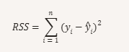
Yi = actual value
-
Yi = predicted value
n is no.of observations
RSS – how far off our predictions are
- Lower RSS better fit
- Helps to optimize model parameters (ex via gradient descent)

TSS – total sum of squares
- It measures total variance in actual data / how much the values deviate from mean

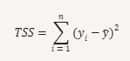
Yi = actual values
-
Y = mean of actual values

TSS is baseline error – if predicted mean for every data point
- It’s the benchmark for evaluating how much variance your model explains

R^2
It quantifies how well the model explains the variance in the data

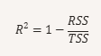

R^2 = 1 perfect prediction
R^2 = 0 model is no better than predicting the mean
R^2 <0 model is worse than the mean

Term | Meaning | Formula
Intercept (Bo) | Value of y when x=0
Slope (B1) | For every Change in y change in x
Residuals | Errors between actual and predicted | e=yi – bar yi
RSS | Residual sum of squares | Refer above
TSS | Total sum of squares | Refer above
R^2 | Proportion of Variance | Refer above

Multiple linear regression
- It’s used to model the relationship between one dependent variable and two or more independent variables. This extends simple linear regression by allowing for multiple predictors

Y = predicted outcome
X1,X2,X3……: input features
Bo : intercept
B1, B2, B3…..coefficients
E – error term

Ex
Predict house price based on size and no.of bed rooms

Size (sqft) | Bedrooms | Price (lakhs)
1000 | 2 | 50
1500 | 3 | 70
2000 | 4 | 90
1200 | 2 | 55
1800 | 3 | 80

Price = Bo + B1.size+B2.bedrooms
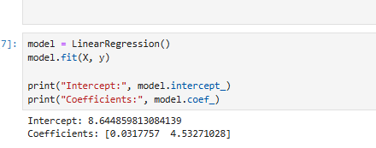

Lets predict price of a new hours
Size = 1600 sft
Bedrooms = 3
Price = 8.64 + (0.0318 x 1600) + (4.53 x 3) = 8.64 + 50.88 + 13.59 = Rs. 73.11 lakh

Regression for continuous output
Regression is used when the target variable is continuous –
- House prices
- Temperature
- Sales revenue

Predict student exam score based on
- Hours studied
- No.of practice problems solved

<<refer the program for rest of the steps>>

Classification

It’s used when the output variable is categorical –
- Spam vs Ham
- Disease vss no disease

The model learns from labeled data and predicts the class for unseen inputs
<<refer program>>

[“win”, “free”, ”meeting”, ”cheap”, ”cash”]

win a free iPhone now! [1, 1, 0, 0, 0]

